1. **Write a program to classify a given dataset using the support vector machine.**

# Import necessary libraries

import numpy as np

import pandas as pd

from sklearn.model_selection import train_test_split

from sklearn.svm import SVC

from sklearn.metrics import accuracy_score, classification_report

from sklearn.preprocessing import StandardScaler

# Load dataset (replace with your dataset)

# For demonstration, we'll use the Iris dataset from scikit-learn

from sklearn.datasets import load_iris

data = load_iris()

# Extract features and labels

X = data.data

y = data.target

# Split the dataset into training and testing sets

X_train, X_test, y_train, y_test = train_test_split(X, y, test_size=0.3, random_state=42, stratify=y)

# Standardize the features (important for SVM performance)

scaler = StandardScaler()

X_train = scaler.fit_transform(X_train)

X_test = scaler.transform(X_test)

# Create the SVM model (you can experiment with different kernels: 'linear', 'rbf', 'poly', etc.)

svm_model = SVC(kernel='rbf', C=1.0, gamma='scale', random_state=42)

# Train the SVM model

svm_model.fit(X_train, y_train)

# Make predictions on the test set

y_pred = svm_model.predict(X_test)

# Evaluate the model

accuracy = accuracy_score(y_test, y_pred)

print("Accuracy:", accuracy)

print("\nClassification Report:\n", classification_report(y_test, y_pred, target_names=data.target_names))

# Optional: Make a prediction for new data

new_data = np.array([[5.1, 3.5, 1.4, 0.2]]) # Replace with your own data

new_data_scaled = scaler.transform(new_data)

prediction = svm_model.predict(new_data_scaled)

print("\nPrediction for new data:", data.target_names[prediction[0]])

**OUTPUT:**

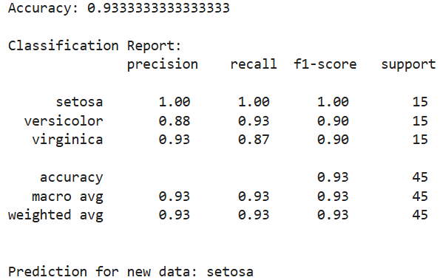

1. **Write a program to demonstrate ensemble learning with any classifier on a given dataset.**

#pip install numpy pandas scikit-learn matplotlib

import numpy as np

import pandas as pd

import matplotlib.pyplot as plt

from sklearn.datasets import load_iris

from sklearn.model_selection import train_test_split

from sklearn.ensemble import RandomForestClassifier

from sklearn.metrics import classification_report, confusion_matrix, accuracy_score

# Load the Iris dataset

iris = load_iris()

X = iris.data

y = iris.target

# Split the dataset into training and testing sets

X_train, X_test, y_train, y_test = train_test_split(X, y, test_size=0.2, random_state=42)

# Create a Random Forest Classifier

rf_classifier = RandomForestClassifier(n_estimators=100, random_state=42)

# Train the classifier

rf_classifier.fit(X_train, y_train)

# Make predictions

y_pred = rf_classifier.predict(X_test)

# Evaluate the model

print("Confusion Matrix:")

print(confusion_matrix(y_test, y_pred))

print("\nClassification Report:")

print(classification_report(y_test, y_pred))

print("Accuracy Score:", accuracy_score(y_test, y_pred))

# Feature Importance

feature_importances = rf_classifier.feature_importances_

features = iris.feature_names

# Plotting feature importances

plt.figure(figsize=(10, 6))

plt.barh(features, feature_importances, color='skyblue')

plt.xlabel('Feature Importance')

plt.title('Feature Importance in Random Forest Classifier')

plt.show()

**OUTPUT:**

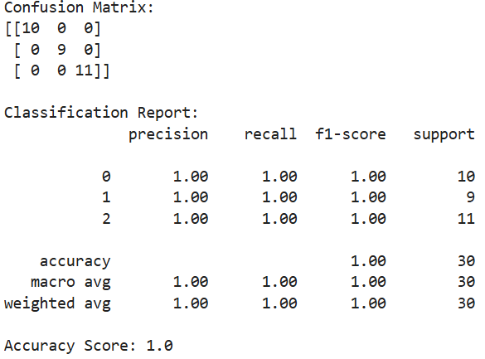

1. **Apply EM algorithm to cluster a set of data stored in a .CSV file. Use the same data set for clustering. using the k-Means algorithm. Compare the results of these two algorithms and comment on the quality of clustering. You can add Java/Python ML library classes/API in the program.**

import pandas as pd

import numpy as np

import matplotlib.pyplot as plt

from sklearn.datasets import load_iris

from sklearn.cluster import KMeans

from sklearn.metrics import accuracy_score, silhouette_score

iris = load_iris()

x = pd.DataFrame(iris.data, columns=iris.feature_names)

y = iris.target

plt.figure(figsize=(20,7))

plt.subplot(1, 2, 1)

plt.scatter(x['sepal length (cm)'], x['sepal width (cm)'], c=y, s=40)

plt.title('Sepal')

plt.subplot(1, 2, 2)

plt.scatter(x['petal length (cm)'], x['petal width (cm)'], c=y, s=40)

plt.title('Petal')

model = KMeans(n_clusters=3)

model.fit(x)

model.labels_

accuracy_score(y, model.labels_)

from sklearn.mixture import GaussianMixture

GMM = GaussianMixture(n_components=3) # Instantiate and fit the model

GMM.fit(x)

gmm_clusters = GMM.predict(x)

gmm_clusters

accuracy_score(y, gmm_clusters)

plt.figure(figsize=(17,7))

plt.subplot(1, 3, 1)

plt.scatter(x['petal length (cm)'], x['petal width (cm)'], c=y, s=40)

plt.title('Actual Classes')

plt.subplot(1, 3, 2)

plt.scatter(x['petal length (cm)'], x['petal width (cm)'], c=model.labels_,

s=40)

plt.title('KMeans Clusters')

plt.subplot(1, 3, 3)

plt.scatter(x['petal length (cm)'], x['petal width (cm)'], c=gmm_clusters, s=40)

plt.title('EM Clusters')

**OUTPUT :**



